**NYC Restaurant Sales Analysis**:

Business Questions:

* **How was the impact of each item on total revenue generated?**
* **What is the distribution of sales across different transaction types?**
* **Do sales patterns differ based on the combination of gender and time of sale?**
* **How sales are changing through out the week based on each day also weekday/weekend**
* **What was the best item based on the timeofsale**

**Step 1: Data Collection**

Data for the project was collected through an API, providing raw information for analysis and processing.

Data was collected from rapidapi,created an json file then using pandas it was transformed into data frame then an Excel File

**Step 2: Data Cleaning in Excel**

Handling Duplicates:

* Removed duplicate entries to ensure data integrity and accuracy.

Adjusting Date Formats:

* Replaced "/" with "-" to standardize date formats for consistency.
  + Formula Used: **=IF(MID(A1, 2, 1) = "-", "0" & A1, A1)**
* Converted date values to Excel's standard date format.
  + Formula Used: **=IF(ISNUMBER(K2), DATE(1900,1,1) + K2- 1, DATE(RIGHT(K2, 4), LEFT(K2, 2), MID(K2, 4, 2)))**

Changing Fields:

* Renamed "received by" field to "gender" for clarity and consistency.
* Populated empty values in the payment field with "others" to ensure completeness of the dataset.

**Step 3: Data Analysis**

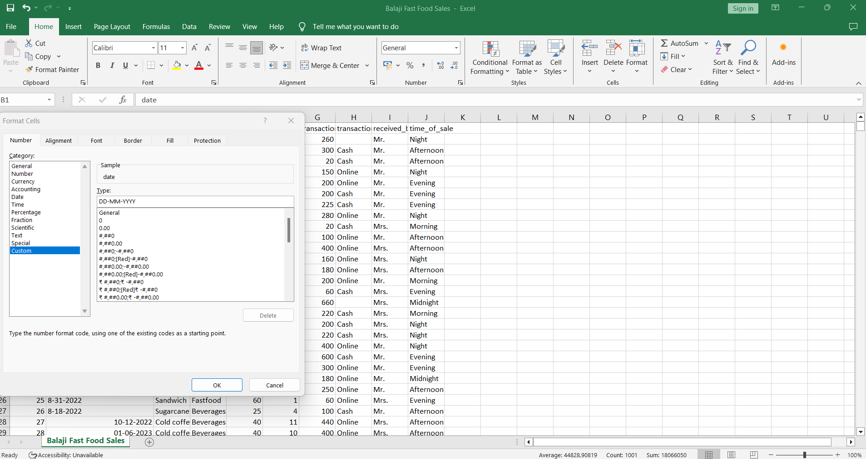

Upon Analysis of the Data they were Some KPI’S

1.Revenue per ITEM

2.TOTAL ORDERS EACH ITEM GENERATED

3.Total Quantity

**4.Create SQL Database and Fetching Queries**

In this step we create an SQL database ,in that database we created an table and attached the cleaned excel file to this database and upon creating we wrote some queries to answer business questions

SQL QUERY:

1.

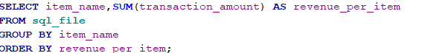

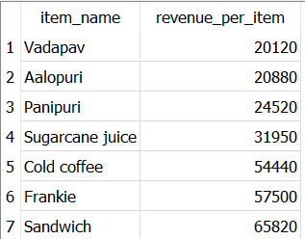

2. 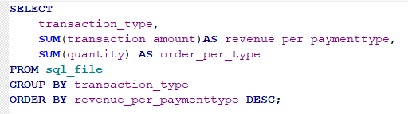

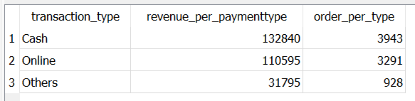

3

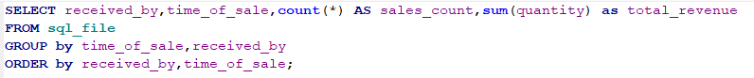

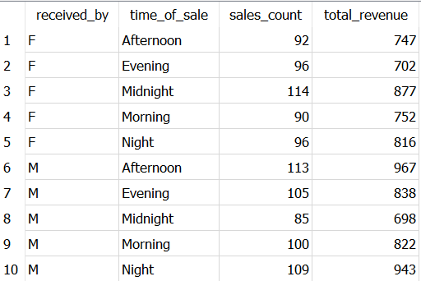

4.

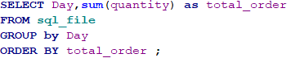

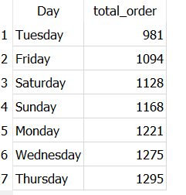

5.

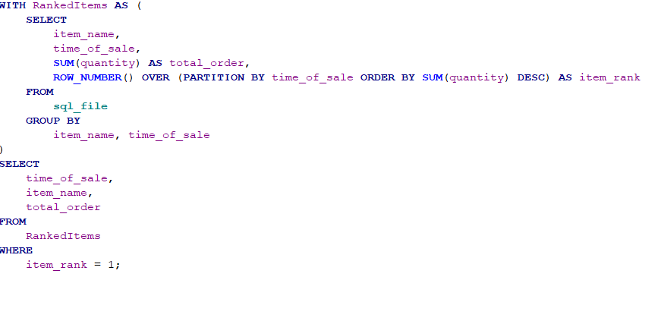

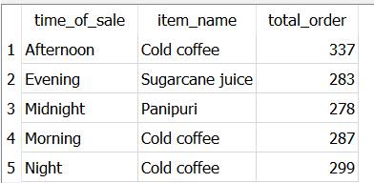

**5.Live Dashboard Creation (PowerBI):**

Created a dashboard using the data by pinning tiles with KPI’s mentioned alongside presenting visual insights about the best seller item, revenue generated based on type of transactions etc.

This dashboard is published on web:

<https://app.powerbi.com/groups/me/dashboards/9c16a702-f465-4fc3-9bf6-77aea60a7f77?ctid=96464a8a-f8ed-40b1-99e2-5f6b50a20250&experience=power-bi>

**INSIGHTS:**

* Sandwich and Cold coffee are the most profitable, and in demand can increase the price of items by 10% to increase revenue by 15%
* Weekend people tend to go for sandwich and sugarcane juice
* Both Cash and Online tends to go for 90% while undisclosed 10% can lead to potential losses which restaurant needs to minimize